Project Design Phase-II
Data Flow Diagram & User Stories
Date | 21/09/2026
Team ID | SWTID-2026-9516
Project Name | AI FAQ Assistant
Maximum Marks | 4 Marks

Data Flow Diagrams:
A Data Flow Diagram (DFD) represents the information flows within the AI FAQ Assistant. It shows how a customer submits a question, how the AI FAQ Assistant retrieves relevant information from the FAQ/knowledge base, how an answer is returned, how sessions are stored, and how an administrator manages FAQ content and views system status or analytics.
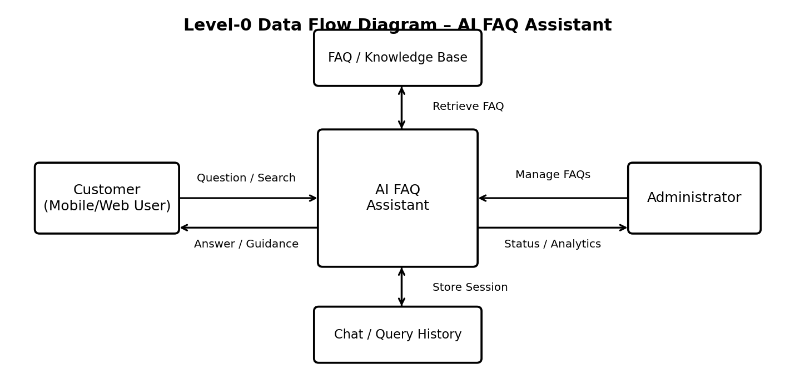
Figure 1: Simplified Level-0 DFD for the AI FAQ Assistant

User Stories
The following user stories are tailored to the AI FAQ Assistant and retain the User Type, Functional Requirement (Epic), User Story Number, User Story / Task, Acceptance criteria, Priority and Release structure from the provided template.
User Type | Functional Requirement (Epic) | User Story Number | User Story / Task | Acceptance criteria | Priority | Release
Customer (Mobile user) | Registration | USN-1 | As a user, I can register for the AI FAQ Assistant using my email and password. | I can create an account and access the application. | High | Sprint-1
 | Login | USN-2 | As a user, I can log into the application using my registered email and password. | I can successfully access the AI FAQ Assistant after valid login. | High | Sprint-1
 | Ask FAQ | USN-3 | As a user, I can enter a question and receive an AI-generated answer based on the available FAQs. | The system displays a relevant answer for the submitted question. | High | Sprint-1
 | FAQ Search | USN-4 | As a user, I can search or enter keywords to find relevant frequently asked questions. | Relevant FAQ results are displayed for the entered keywords. | High | Sprint-1
 | Answer Feedback | USN-5 | As a user, I can provide feedback on whether an AI FAQ answer was helpful. | The system records the submitted feedback. | Medium | Sprint-2
 | Chat History | USN-6 | As a user, I can view my recent questions and answers during my sessions. | Previous questions and responses are displayed in the chat/session history. | Medium | Sprint-2
Customer (Web user) | Ask FAQ | USN-7 | As a web user, I can ask questions through the AI FAQ Assistant on a web interface. | The web interface accepts the question and displays the response. | High | Sprint-1
 | Escalation | USN-8 | As a web user, I can request assistance from customer care when the FAQ assistant cannot resolve my question. | The request is submitted for customer care follow-up. | Medium | Sprint-2
Customer Care Executive | Query Handling | USN-9 | As a customer care executive, I can view escalated questions that require human assistance. | Escalated questions are available for review and response. | High | Sprint-2
 | Response Management | USN-10 | As a customer care executive, I can provide a response to an escalated customer query. | The response is recorded and made available to the customer. | Medium | Sprint-2
Administrator | FAQ Management | USN-11 | As an administrator, I can add, edit, and remove FAQ entries in the knowledge base. | FAQ content can be created, updated, or removed successfully. | High | Sprint-1
 | Knowledge Base | USN-12 | As an administrator, I can manage the information used by the AI FAQ Assistant to answer questions. | Updated knowledge-base content is available to the assistant. | High | Sprint-2
 | Monitoring & Analytics | USN-13 | As an administrator, I can view basic usage information such as questions, feedback, and escalations. | The system displays the available usage and feedback information. | Medium | Sprint-2

Note: The original template contained sample registration/login stories and blank role sections. They have been replaced with project-specific stories for the AI FAQ Assistant while keeping the template's structure.

